Instructions for the Preparation of Abstract Submission
(Title font size 12 pt)
Author Name1 ª, Author Name2 ^{a *}, Author Name3 ^{b}
ª Department, University, City, Postal Code, Country
^{b} Department, University, City, Postal Code, Country
Abstract (Font size 11 pt, 150 words)
The abstract contains a summary of the entire paper and can be up to 150 words long with only one paragraph. It must not contain any images or tables (although a graphical abstract may also be submitted). Do not included running title, website links, equations, figures (or other graphical elements), tables, or structures that require display on a line separate from the text. The font size for the paper title is 11 points and that for the text is 10 points.
Authors should follow the style of a structured abstract, which is based on the structure of a paper but without using headings. In other words, give a background and motivation to the paper, a brief description of the methods, the principal results, and then conclusions or interpretations. Abstracts without headings should consist of a single paragraph.
Abstracts must be self-contained: they are often displayed and read independently of the rest of the paper. This means that any abbreviations used must be defined in the abstract, and no reference can be made to the bibliography or any figures. Citations to previously published papers are not required in abstracts.
The abstract, along with the main title, is the first part of your paper that a reader will see. It should give them a good overview of all the major aspects of the work carried out. It should not be thought of as a sales pitch to encourage readers to download and read the full article, although including some motivation is a good idea. Instead, you should focus on making it informative and comprehensive. A well-written abstract will mean that someone who goes on to read the full article will already have a good idea of the content and will be able to focus on the parts they are most interested in.
Keywords—component, formatting, style, styling, insert (limited to five keywords only)
- Introduction (font size 11 pt, Heading 1)
This template, modified in MS Word 2007 and saved as a “Word 97-2003 Document” for the PC, provides authors with most of the formatting specifications needed for preparing electronic versions of their papers. All standard paper components have been specified for three reasons: (1) ease of use when formatting individual papers, (2) automatic compliance to electronic requirements that facilitate the concurrent or later production of electronic products, and (3) conformity of style throughout a conference proceedings. Margins, column widths, line spacing, and type styles are built-in; examples of the type styles are provided throughout this document and are identified in italic type, within parentheses, following the example.

Authors may determine the sessions according to their paper contents.
Tab 1. Example of tables (Table caption, 8 points)

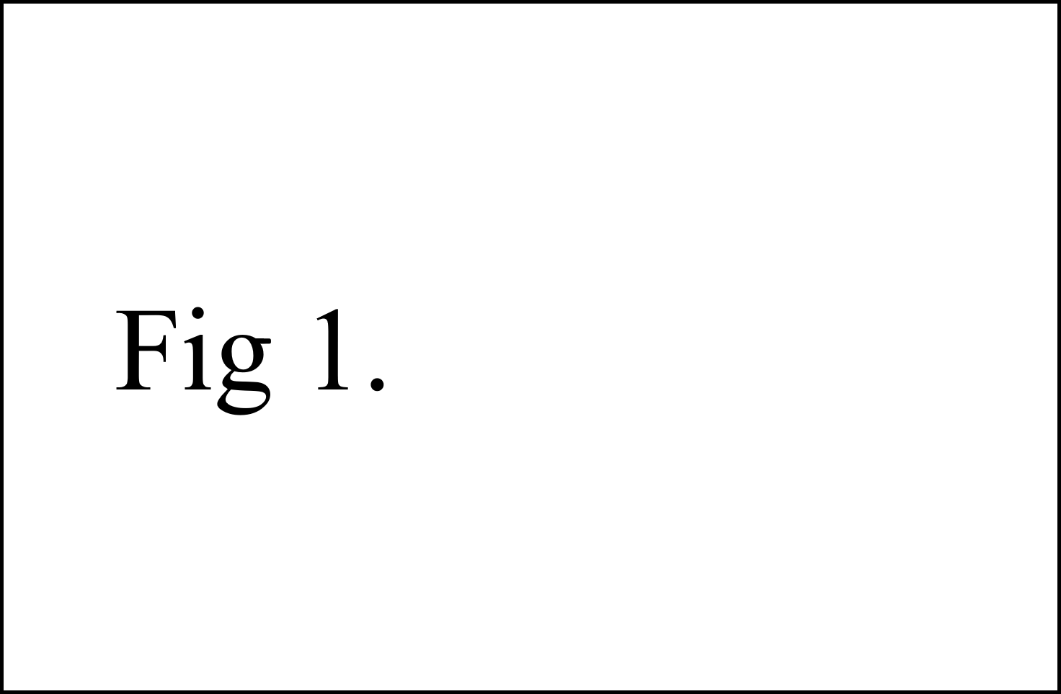
Fig 1. Example of figures (Figure caption, 8 points)
- Literature review
References should be numbered in order of appearance and indicated by a numeral or numerals in square brackets—e.g., [1] or [2,3], or [4–6].

- Results
This section may be divided by subheadings. It should provide a concise and precise description of the experimental results, their interpretation, as well as the experimental conclusions that can be drawn.

3.1. Subsection (Font size 10 points ,Heading 2)
This is an example of equation:
 | a + b = 1, | (1)

3.1.1. Subsubsection (font size 10 points, Heading 3)

Acknowledgments

References (limited to 15 key references only). See examples of reference style below.
[1] Chen, J.K., Kim, Y.S., Lim, S. and Patton, J., 2018. River-Sea Combined Transport. Journal of International Maritime Transport, 24(1), 123-130.
[2] Smith, J. and Gratton, P., 2016. Dynamics of Logistics in the Globalized Economy. Published city: Publishing Company.
(* In case of website citation, please indicate the accessed date after the website.)

This paper template contains instructional text for writing and formatting conference papers. Please ensure that you remove all template text from your paper before submitting it to the conference. Failure to remove boilerplate text from a paper may result in the paper not being published.

